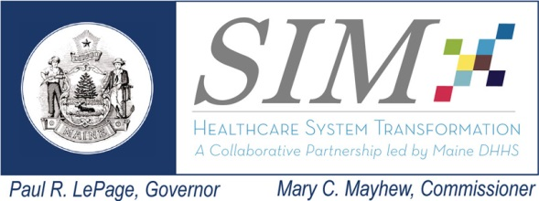
Subcommittee: Payment Reform
Date: April 21, 2015
Time: 3:00 to 5:00 pm
Location: Maine Medical Association,
Manchester

Chair Frank Johnson
Core Member Attendance: Andrew Ellis, Anthem BCBS (remote); Pat Denning, Harvard Pilgrim (remote; Fan Jenseon, CMMI (remote); Jim Kane, Central Maine Healthcare; John Keiming, Healthcentric Advisors; Peter Kraut, MaineCare; Wanda Pelkey, First Atlantic (remote); Michelle Probert, Bath Iron Works; Jeff Smorczewski, Aetna;

Interested Parties & Guests: Lisa Letourneau, Quality Counts; Christopher Pezzullo, MaineCare; Lisa Tuttle, Quality Counts; David Winslow, Maine Hospital Association;

Staff: Lisa Nolan, MHMC; Blake Hendrickson, MHMC.

Topics | Lead | Notes | Actions/Decisions
- Primary Care Spend Objective | Frank Johnson | Frank update the Subcommittee on the ongoing efforts to define and calculate primary care spend as a percentage of total healthcare expenditures. | There was no action taken as this was an informational update only.
- Update on CMS RFI on advanced primary care models and CPC model | Lisa Letourneau | Dr. Letourneau briefed the Subcommittee on the PCMH conveners join response to the CMS Request for Information on the key components for advanced primary care payment models. Dr. Letourneau also provided background on the CMS Primary Care Payment Initiative (CPC) that has been introduced in seven regions/states. | There was no action taken as this was an informational update only.
- Discern report on Innovative Payment for Advanced Primary Care | Frank Johnson & Dr. Lisa Letourneau | Frank and Dr. Letourneau provided a review of the report prepared by Discern Health and noted that the MHMC and the Maine Medical Association are co-sponsoring a presentation of Discern’s findings and recommendations at the ACI Steering Committee’s April 24th meeting. Guy D’Andrea from Discern will be in attendance for the presentation. An objective of the Discern presentation is to consider primary care models that may be appropriate for the Maine market. | There was no action taken as this was an informational update only.
- SIM States’ Opportunity for CMS Participation in State Sponsored Initiatives | Frank Johnson & Dr. Lisa Letourneau | Frank and Dr. Letourneau shared the recent CMS announcement to SIM sates that there is an opportunity to submit proposals for aligned multi-payer payment reform and delivery system initiatives with Medicare participation. There was considerable discussion on the value of this opportunity and the need for Maine to be poised to develop a proposal should the State decide to pursue the CMS invitation. There was general agreement that a multi-stakeholder work group, similar to that of the PCMH pilot, should be convened to develop a proposal. It was also recognized that the Payment Reform Subcommittee and the ACI Committee would most likely serve to convene the work group and keep stakeholders apprised. | There was no action taken as this was an informational discussion.
- Update on SIM Steering Committee Actions | Frank Johnson | Frank advised the Subcommittee that the SIM Steering Committee has approved the recommendations of the ACI Measure Alignment Work Group and has approved the process for the Cost of Care Work Group’s recommendation for a voluntary annual growth cap on risk-based contracts The Steering Committee has deferred action on public reporting of TCI/RUI pending PTE and MHMC board approval of a modified methodology. | This was informational only.
- Interested Parties Public Comment | All | There was no public comment. | DNA
Next Meeting |  | Further dialogue on the CMS aligned multi-payer opportunity and advanced primary care payment models

Next Meeting:

June 16, 2015
Location TBD

